

SMART KTM MALAYSIA MOBILE APPLICATION

CHEW JIE WEEI
(SCSJ2500057)

Ts. UMI KALSUM BINTI MUHAMAD
20 JULY 2026

REPORT SUMITTED TO FULFIL PARTIAL REQUIREMENTS FOR THE CERTIFICATE IN INFORMATION TECHNOLOGY

SEGI SUBANG JAYA

DECLARATION
I hereby declare that this final year research project is based on my original work except for citations and quotations which have been duly acknowledged. I also declare that it has not been previously and concurrently submitted for any other diploma or award at SEGI College or other institutions.

Signature :
Name : Chew Jie Weei
Student ID : SCSJ2500057
Date : 18.07.2026

Signature :
Lecturer’s name : Ts. UMI KALSUM BINTI MUHAMAD
Date :

ACKNOWLEDGEMENTS
I would like to express my sincere gratitude to everyone who has contributed to the successful completion of this Final Year Project entitled “Smart KTM Malaysia Mobile Application Prototype.”
First and foremost, I would like to express my heartfelt appreciation to my supervisor for providing continuous guidance, valuable advice, constructive feedback and encouragement throughout the development of this project. Her patient and support have helped me overcome many challenges during the research and prototype development process.
I would also like to thank all the lecturer of SEGI COLLEGE SUBANG JAYA for sharing their knowledge and providing the necessary skills and learning opportunities throughout my studies. Their teaching has greatly contributed to the successful completion of this project.
My sincere appreciation also goes to my family and my friends for their continuous encouragement, understanding and moral support. Their motivation has inspired me to remain focused and complete this project successfully.
Finally, I would like to thank all the respondents who participated in the user testing and questionnaire. Their valuable feedback and suggestions have contributed significantly to the evaluation and improvement of the Smart KTM Malaysia Mobile Application Prototype.

ABSTRACT
The Smart KTM Malaysia Mobile Application Prototype was developed to improve the travel experience of KTM passengers by providing convenient access to train information and services through a mobile application. Many passengers face difficulties in monitoring train locations, identifying less crowded coaches and purchasing ticket efficiently, which may lead to inconvenience during their journeys. Therefore, this project proposes a mobile application prototype that integrates passenger monitoring, live train tracking and online ticket booking into a single platform.
The prototype was developed using the Prototype Development Methodology, which consists of requirement gathering, quick design, prototype development, user evaluation and prototype refinement. The application was designed using Figma to demonstrate the proposed system functions and user interface. Prototype testing and user testing were conducted to evaluate the functionality, usability and overall user satisfaction of the proposed application.
The evaluation results indicate that the prototype successfully achieved the project objectives. Users were able to navigate the application easily and considered the passenger monitoring, live train tracking and online ticket booking features useful for improving their travel experience. Although the application is currently a prototype and does not integrate with real-time KTM systems, it provides a practical foundation for future development and implementation.

ABSTRACT
Prototaip Smart KTM Malaysia Mobile Application dibangunkan untuk meningkatkan pengalaman perjalanan penumpang KTM dengan menyediakan akses yang lebih mudah kepada maklumat dan perkhidmatan kereta api melalui aplikasi mudah alih. Ramai penumpang menghadapi kesukaran untuk menjejaki Lokasi kereta api, mengenal pasti gerabak yang kurang sesak dan membeli tiket dengan lebih cekap, sekali gus menyebabkan kesulitan semasa perjalanan. Oleh itu, projek ini mencadangkan satu prototaip aplikasi mudah alih yang menggabungkan pemantauan penumpang, penjejakan kereta api secara langsung dan tempahan tiket dalam talian dalam satu platform.
Prototaip ini dibangunkan menggunakan Metodologi Pembangunan Prototaip yang terdiri daripada fasa pengumpulan keperluan, reka bentuk awal, Pembangunan prototaip, penilaian pennguna dan penambahbaikan prototaip. Aplikasi ini direka menggunakan Figma bagi menunjukkan fungsi sistem dan reka bentuk antara muka pengguna yang dicadangkan. Ujian prototaip dan ujian pengguna telah dijalankan untuk menilai fungsi, kebolehgunaan dan tahap kepuasan pengguna terhadap aplikasi yang dicadangkan.
Hasil penilaian menunjukkan bahawa prototaip ini berjaya mencapai objektif projek. Pengguna dapat menggunakan aplikasi dengan mudah dan berpendapat bahawa ciri pemantauan penumpang, penjejakan kereta api secara langsung dan tempahan tiket dalam talian dapat membantu meningkatkan pengalaman perjalanan mereka. Walaupun aplikasi ini masih berada pada peringkat prototaip dan belum diintegrasikan dengan sistem KTM masa nyata, ia menyediakan asas yang kukuh untuk pembangunan dan pelaksanaan sistem pada masa hadapan.

Table of Contents
DECLARATION 1
ACKNOWLEDGEMENTS 2
ABSTRACT 3
CHAPTER 1 8
INTRODUCTION 8
1.1 Background of the study 8
1.2 Problem Statement 9
1.3 Aim of the Project 9
1.4 Objectives of the Project 9
1.5 Scope of the Project 10
1.6 Project Planning and Timeline 10
1.7 Project Requirement 12
1.8 Conclusion 12
CHAPTER 2 13
LITERATURE REVIEW 13
2.1 Introduction 13
2.1 Real Time Train Tracking System 13
2.2 Mobile Transportation Application and User Acceptance 14
2.3 Service Quality Issues in Malaysian Rail Transit Systems 14
2.4 Comparison of Related Articles 15
2.5 Comparison of Existing Applications and Proposed System 17
2.7 Conclusion 18
CHAPTER 3 19
METHODOLOGY 19
3.1 Introduction 19
3.2 Project Methodology 19
3.2.1 Requirement Gathering 20
3.2.2 Quick Design 20
3.2.3 Prototype Development 21
3.2.4 User Evaluation 21
3.2.5 Refinement 21
3.3 Development Tools and Techniques 21
CHAPTER 4 22
SYSTEM DESIGN AND DEVELOPMENT 22
4.1 Introduction 22
4.2 Use Case Diagram 23
4.3 System Flowchart 24
4.4 User Interface Design 25
4.5 Conclusion 32
CHAPTER 5 33
PROTOTYPE 33
5.1 Introduction 33
5.2 Authentication Prototype 33
5.3 Home Page Prototype 34
5.4 Train Search Page Prototype 35
5.5 Train Search Result Page Prototype 36
5.6 Live Train Tracking Page Prototype 37
5.7 Ticket Booking Page Prototype 38
5.8 Account Management Page Prototype 39
5.9 Conclusion 40
CHAPTER 6 41
TESTING AND EVALUATION 41
6.1 Introduction 41
6.2 Prototype Testing Evaluation 41
6.2.1 Prototype Testing Result 42
6.3 User Testing Evaluation 42
6.3.1 Questionnaire Results 43
6.4 Evaluation Based on Project Objectives 44
6.5 System Strengths and Limitations 44
6.5.1 System Strengths 45
6.5.2 System Limitations 45
6.6 Conclusion 45
CHAPTER 7 47
CONCLUSION AND RECOMMENDATIONS 47
7.1 Introduction 47
7.2 Conclusion 47
7.3 Future Recommendations 47
Reference 49
1.0 Introduction 52
1.1 Problem Statement 53
2.0 Aim of the Project 54
2.1 Objectives of the Project 54
3.0 Literature Review 55
3.1 Real Time Tracking System 55
3.2 Mobile Transportation Application and User Acceptance 55
3.3 Key Service Quality Issues in Malaysian Rail Transit 56
4.0 Methodology 57
4.1.1 Requirement Gathering 57
4.1.2 Quick Design 57
4.1.3 Prototype Development 57
4.1.4 User Evaluation 58
4.1.5 Refinement 58
4.2 Approach 58
5.0 Project Plan 58
6.0 Conclusion 59
Reference 60

CHAPTER 1

INTRODUCTION

1.1 Background of the study
Public transportation plays an important role in Malaysia, as many people rely on train services for daily travel, particularly in urban areas such as Kuala Lumpur and Selangor. KTM Malaysia is one of the main railway transportation providers in the country and is widely used by students, workers, and tourists due to its affordability and accessibility. However, passengers often face several issues when using KTM services, including delays, overcrowded coaches during peak hours, and difficulties in obtaining accurate train information (Khalid et al., 2014).
With the rapid advancement of mobile technology and smart transportation systems, passengers today increasingly expect faster, smarter, and more convenient transportation services through mobile applications (Biyik et al., 2021). Many users prefer to receive real-time information directly on their smartphones rather than relying on station announcements or physical ticket counters. In addition, real-time information systems have been shown to improve transportation efficiency and enhance passenger experience by providing live tracking and estimated arrival times (Ganesh et al., 2012). Furthermore, mobile-based transportation solutions are becoming an essential component of modern smart mobility systems, enabling better communication between service providers and passengers (Husnina et al., 2022).
Therefore, this project is designed to develop a Smart KTM Malaysia mobile application prototype that integrates real-time train tracking, passenger crowd monitoring, and online ticket booking features. The system enables users to track train locations more efficiently, identify less crowded coaches before boarding and purchase tickets digitally through their smartphones. In addition, the system focuses on providing a modern and user-friendly interface using Figma to simulate a realistic mobile application experience.
The proposed system is expected to enhance passenger convenience, reduce waiting times and support the development of smart transportation systems in Malaysia. By integrating tracking, monitoring and ticketing functions into a single platform, the system provides a more efficient, reliable and user-friendly travel experience for KTM passengers.

1.2 Problem Statement
The development of smart transportation systems has become increasingly important in modern society, as people heavily rely on public transportation for daily travel. Mobile applications are widely used to provide users with faster and more convenient access to transportation information and services (Biyik et al., 2021). In Malaysia, KTM is one of the major railway service providers used by thousands of passengers every day. Therefore, this project aims to design a Smart KTM Malaysia mobile application that provides a more modern and interactive experience for train passengers.
Currently, some KTM passengers face difficulties in obtaining accurate train information during their journeys. Users may not be aware of the real-time location of trains, estimated arrival times, or the crowd levels in train coaches. In addition, purchasing tickets at stations can be inconvenient, especially during peak hours when long queues occur. These issues may reduce passenger comfort and negatively affect the efficiency of public transportation services (Khalid et al., 2014). Furthermore, passengers today prefer to receive real-time transportation information through mobile applications rather than relying solely on station announcements (Husnina et al., 2022).
To address these challenges, this project proposes the development of a Smart KTM Malaysia mobile application prototype that includes several smart features, such as real-time train tracking, crowd monitoring, and digital ticket booking. The application will allow users to view and monitor different trains through an interactive map interface while also displaying train status and passenger crowd levels. By integrating these features into a single platform, the proposed system aims to improve user convenience and create a more efficient and intelligent transportation experience.

1.3 Aim of the Project
The aim of this project is to develop a Smart KTM Malaysia mobile application prototype that provides real time train tracking, passenger crowd monitoring and online ticket booking features to improve the convenience, efficiency and overall travel experience of KTM passengers in Malaysia.

1.4 Objectives of the Project
- To implement a Smart KTM Passenger Monitoring System that can estimate the number of passengers in each coach using sensors.
- To design a live train tracking feature that displays the current location of the train through a map interface.
- To implement an online ticket booking feature for KTM services through a mobile application.

1.5 Scope of the Project
This project focuses on designing and developing a Smart KTM Malaysia mobile application prototype using Figma. The prototype is intended to improve the travel experience of KTM passengers by providing important transportation information and services through a mobile application.
The scope of the project includes three main features. The first feature is real-time train tracking, which allows users to view train locations and estimated arrival information through an interactive map interface. The second feature is passenger crowd monitoring, which displays the estimated crowd level of each train coach to help passengers identify less crowded areas before boarding. The third feature is online ticket booking, which enables users to purchase KTM tickets through the mobile application.
In addition, the project focuses on the design of the user interface (UI) and user experience (UX) to ensure that the application is easy to use and visually appealing. Interactive navigation and prototype simulations are developed to demonstrate how the proposed system would function in a real environment.
However, this project is limited to prototype development only. It does not involve actual system implementation, integration with KTM’s operational database, deployment of GPS tracking devices, installation of passenger counting sensors, or real payment gateway integration. The prototype is developed for demonstration and evaluation purposes using Figma.

1.6 Project Planning and Timeline
Project planning is essential to ensure that the Smart KTM Malaysia Mobile Application is completed successfully within the allocated timeframe. A Gantt chart is used to present the project schedule, task duration and key development activities. It provides a clear overview of the project timeline and helps monitor progress throughout the development process.
The project follows the Rapid Prototyping Model and is divided into several phases, namely Requirement Gathering, Quick Design, Prototype Development, User Evaluation, Prototype Testing and Refinement and Final Presentation Preparation. Each phase is assigned a specific duration and set of tasks to ensure systematic development and timely completion of this project. Through proper planning and scheduling, the project team can effectively manage resources, track progress and achieve the project objectives
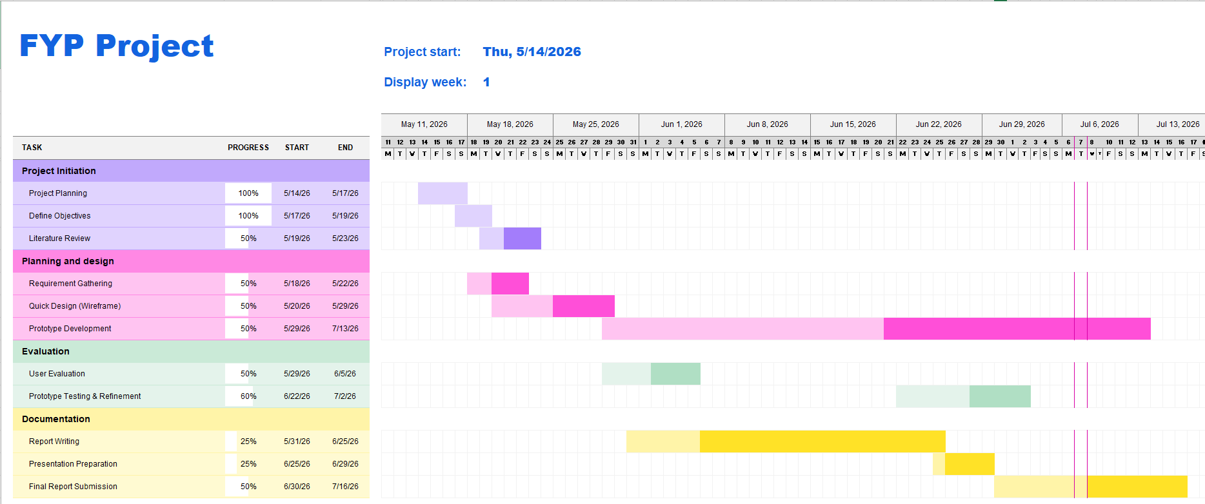
Figure 1.1:Project Planning Timeline
Figure 1.1 shows the project planning schedule for the Smart KTM Malaysia Mobile Application Prototype. The Gantt Chart presents the timeline and duration of each activity involved in the project. The project begins with project planning, requirement gathering and literature review, followed by the quick design and prototype development phases. After the prototype is developed, user evaluation and prototype testing are conducted to improve the application based on user feedback. Finally, the project concludes with report writing, final prototype improvement, report submission and presentation preparation. This project planning helps ensure that all tasks are completed systematically and within the allocated time.

1.7 Project Requirement
This section describes the hardware and software requirements needed to design and develop the Smart KTM Malaysia Mobile Application Prototype. The prototype was created to demonstrate the application’s interface and functionally for train passengers.
The hardware requirements include a laptop or desktop computer with at least an Intel Core i5 processor, 8GB RAM and sufficient storage space to support the design process. A smartphone was also used to preview and evaluate the prototype to ensure that the interface is suitable for mobile devices.
Several software tools were used throughout the project. Figma was used to design the user interface and develop interactive prototypes. Microsoft Excel was used to prepare the project timeline and Gantt Chart. Microsoft Word was used to write and format the project report, while Draw.io was used to create system diagrams such as case diagrams and system flowchart. Google Forms was used to collect user feedback during the evaluation phase of the prototype.

1.8 Conclusion
This is all for Chapter 1 and it basically explains all the useful ideas and plans behind the Smart KTM Malaysia App. The text shows the common problems that passengers face every day and the ideas to fix them. The main goal is to make train travel much better and easier for everyone. To do this, the new app will include many simple tools. For example, the app will let passengers see where the train is right now, check if the train cars are too crowded, buy tickets online without waiting in line and get reward points. In the next chapter, the focus will turn to other similar apps and books to see how this new app can be built in a better way.

CHAPTER 2

LITERATURE REVIEW

2.1 Introduction
This chapter reviews previous studies and literature related to smart transportation systems, mobile transportation applications and railway service quality. The purpose of this literature review is to identify existing research findings, technologies, and challenges related to public transportation systems, particularly railway transportation services.
The review focuses on three main areas: real-time tracking systems, mobile transportation applications and user acceptance, and service quality issues in Malaysian rail transit systems. Previous studies are analysed to understand how technology can improve passenger convenience, transportation efficiency and overall travel experience. In addition, the literature review identifies existing limitations and research gaps that support the development of the proposed Smart KTM Malaysia mobile application.
The findings from this chapter provide the theoretical foundation for the project and justify the need for integrating real-time train tracking, passenger crowd monitoring and online ticket booking features into a single mobile application platform.

2.1 Real Time Train Tracking System
Real-time passenger information is an important component of modern public transport systems as it improves operational efficiency and enhances passenger experience. Ganesh et al. (2012) proposed a real-time passenger information system that provides live vehicle tracking and estimated arrival information for passengers. The system uses GPS technology to improve transportation efficiency and reduce passenger uncertainty during travel. Through real-time updates, passengers are able to monitor vehicle locations more accurately and plan their journeys more effectively. Railway transportation services require efficient transportation management and accurate passenger information to improve passenger satisfaction and transportation efficiency (Khalid et al., 2014). In addition, smart public transportation systems can improve passenger convenience by providing digital transportation services and real-time transportation information (Husnina et al., 2022). However, the proposed system mainly focuses on tracking functions and does not include passenger crowd monitoring or digital ticket booking features. Therefore, this study proposes an improved system by integrating train tracking with additional smart transportation features into a single mobile application.

2.2 Mobile Transportation Application and User Acceptance
The effectiveness of smart transportation systems is highly dependent on user acceptance and adoption of mobile applications. Husnina et al. (2022), using the Unified Theory of Acceptance and Use of Technology (UTAUT), found that facilitating conditions such as smartphone availability and internet access, as well as user occupation, significantly influence the adoption of mobile transportation applications in the Klang Valley. The study also indicated that younger users, particularly those aged 18–29 in the private sector, are more likely to adopt such applications due to their convenience and functional benefits. In addition, Wahab et al. (2025), based on the Theory of Consumption Values, identified that functional value (reliability and punctuality) has the strongest influence on passenger satisfaction, followed by social and conditional values, while epistemic value has minimal impact. This suggests that users prioritize accurate and practical transport information over novelty features. Furthermore, Yusoff et al. (2021) reported that despite significant investment in public transportation infrastructure, private vehicle usage remains dominant in Malaysia. Khor et al. (2024) also highlighted persistent issues such as fragmented ticketing systems and poor intermodal integration, although digital payment systems and real-time data solutions have shown potential in improving system efficiency. Overall, these findings indicate that mobile transportation applications must prioritize reliability, accuracy, and integration of services to improve user acceptance and satisfaction.

2.3 Service Quality Issues in Malaysian Rail Transit Systems
Existing literature consistently identifies several critical service quality issues within Malaysian rail transit systems, particularly KTM Komuter. Reliability and punctuality remain the most significant concerns, as highlighted by Bachok et al. (2013), Khalid et al. (2014) and Wahab et al. (2025), where studies show that only a small proportion of trains operate on time and passengers frequently experience delays. Capacity constraints also contribute to overcrowding, especially during peak hours, where many passengers are unable to board the first available train (Khalid et al., 2014). In addition, Masirin et al. (2017) and Khalid et al. (2014) emphasized that the fragmentation of rail systems and lack of integration between different operators create inefficiencies in passenger movement and ticketing. Information dissemination is another major issue, as passengers often receive insufficient or unclear updates during delays, limiting their ability to make alternative travel decisions (Khalid et al., 2014). Furthermore, safety and security concerns also affect passenger perception, where Wahab et al. (2025) reported issues such as vandalism and crime, while Bachok et al. (2013) identified cases of theft and harassment within rail environments. Overall, these issues highlight significant gaps in reliability, capacity management, system integration, information delivery, and safety. Although mobile-based solutions have the potential to improve these conditions, existing studies have not proposed a fully integrated application addressing all these challenges simultaneously. Therefore, this study proposes a Smart KTM Malaysia application that integrates real-time tracking, crowd monitoring, and unified ticketing to improve overall service efficiency and passenger experience.

2.4 Comparison of Related Articles
Table 2.1: Comparison of related articles
Author | Year | Title | Focus Area | Issues / Problems | What author says on positive (good) points | Author says on negative (bad) points
Ganesh et al. | 2012 | Real Time Passenger Information System | Real time passenger information and vehicle tracking | Passengers often face uncertainty regarding vehicle locations and arrival times. | - Live tracking  - Estimated arrival time  - Better journey planning | - No crowd monitoring  - No ticket booking  - Only focuses on tracking
Khalid et al. | 2014 | Railway Transportation Service Quality | KTM railway service quality and passenger satisfaction | Train delays, overcrowding and inaccurate passenger information affect user satisfaction. | - Improve passenger satisfaction  - Better service management | - Train delays  - Overcrowded coaches  - Inaccurate information
Husnina et al. | 2022 | Adoption of Mobile Transportation Applications using UTAUT | User acceptance of transportation mobile applications | Limited adoption of transportation applications among certain user groups. | - Real time information  - Convenience  - Easy access | - Depends on smartphone availability  - Depends on internet access
Biyik et al. | 2021 | Smart Transportation and Mobile Technologies | Smart transportation systems and mobile applications | Traditional transportation services often lack fast and accessible digital services. | - Faster information access  - Better accessibility | - Does not focus on railway specific problems
Wahab et al. | 2025 | Passenger Satisfaction in Rail Transit Services | Passenger satisfaction and service quality | Poor reliability and punctuality reduce passenger satisfaction. | - Reliability improves satisfaction  - Better service quality | - Poor punctuality  - Service delays
Yusoff et al. | 2021 | Public Transportation Usage in Malaysia | Public transportation adoption | Public transportation usage remains lower than expected despite infrastructure investments. | - Digital payment systems  - Real time data solutions | - Poor intermodal integration
Khor et al. | 2024 | Transportation System Integration | Integration of transportation systems and ticketing services | Fragmented ticketing systems and weak intermodal integration reduce efficiency. | - Supports transportation development | - High dependency on private vehicles
Bachok et al. | 2013 | Railway Service Performance and Passenger Experience | Railway service performance and passenger satisfaction | Service reliability and safety concerns affect passenger experience. | - Improves passenger confidence | - Theft and harassment issues  - Reliability concerns

Table 2.1 presents a comparison of related studies on transportation systems, mobile applications and railway service quality. The table summarizes the focus area, issues discussed, as well as the positive and negative findings of each study. This comparison helps identify existing limitations and supports the need for developing the proposed Smart KTM Malaysia mobile application.

2.5 Comparison of Existing Applications and Proposed System
Table 2.2 Comparison of Existing Applications and Proposed System
Features | KTM Mobile (KTMB) | Moovit | Google Maps | Proposed Smart KTM
Train Schedule | Yes | Yes | Yes | Yes
Ticket Booking | Yes | No | No | Yes
Real-Time Train Tracking | No | Yes | Limited | Yes
Coach Crowd Monitoring | No | No | No | Yes
QR Code Ticket | Yes | No | No | Yes
Reward Points | No | No | No | Yes
Push Notifications | Yes | Yes | Yes | Yes
User Profile Management | Yes | Yes | Yes | Yes
Table 2.2 compares the features provided by the existing applications and the proposed Smart KTM Malaysia Mobile Application Prototype. Existing applications such as KTM Mobile, Moovit and Google Maps provide useful features including train schedules, ticket booking and navigation services. However, they do not provide all the functions required to improve the overall travel experience of KTM passengers.

The proposed Smart KTM application integrates several additional features, including real time train tracking, coach crowd monitoring, QR code ticketing and reward points. These features are designed to provide a more convenient and user-friendly experience for passengers while encouraging frequent use of KTM services.

2.6 Research Gap
Existing studies on public transportation systems mainly focus on individual aspects such as real-time tracking systems, passenger satisfaction, service quality, and mobile application adoption. Previous research has shown that real-time transportation information can improve passenger convenience and transportation efficiency. In addition, studies related to user acceptance emphasize the importance of reliable and accessible mobile transportation services.
However, most existing studies and transportation applications only focus on specific functions rather than providing a fully integrated solution for railway passengers. Current systems often lack features such as passenger crowd monitoring and unified digital ticket booking within a single mobile platform. Furthermore, limited studies specifically focus on KTM Malaysia passenger needs and the integration of multiple smart transportation features into one user-friendly mobile application.
Therefore, there is a research gap in developing an integrated Smart KTM Malaysia mobile application that combines real-time train tracking, passenger crowd monitoring, and online ticket booking features. This study aims to address these limitations by proposing a prototype system that improves passenger convenience, accessibility, and overall travel experience through a centralized smart transportation platform.

2.7 Conclusion
In conclusion, this chapter reviewed the related literature and existing applications related to public transportation and mobile application services. The discussion included previous studies, existing applications such as KTM Mobile, Moovit and Google Maps, as well as a comparison between these applications and the proposed Smart KTM Malaysia Mobile Application Prototype. The comparison shows that although existing applications provide useful features such as train schedules, route planning and ticket booking, they have limitations in areas such as real time train tracking, coach crowd monitoring and integrated reward features. Therefore, the proposed Smart KTM prototype aims to provide a more convenient and user-friendly solution for KTM passengers. The next chapter explains the research methodology used to design and develop the proposed prototype.

CHAPTER 3

METHODOLOGY

3.1 Introduction
This chapter explains the methodology used to develop the Smart KTM Malaysia Mobile Application Prototype. It describes the approach followed to complete the project in a systematic and organized manner.
The chapter includes the Prototype Development Methodology and explains each phase involved in the development process, including Requirement Gathering, Quick Design, Prototype Development, User Evaluation and Prototype Testing and Refinement. Each phase describes the activities carried out during the development of the prototype.
The purpose of this chapter is to explain how the prototype was developed step by step, from identifying user requirements to evaluating and improving the prototype, to ensure that it meets the project objectives and user needs.

3.2 Project Methodology
This project uses the Prototype methodology. This methodology focuses on developing an early version of the Smart KTM Malaysia mobile application to gather feedback and improve the design before actual implementation. This approach is suitable because the project mainly involves designing and evaluating a mobile application prototype using Figma. Through iterative refinement, the prototype can be improved based on user requirements and usability considerations.
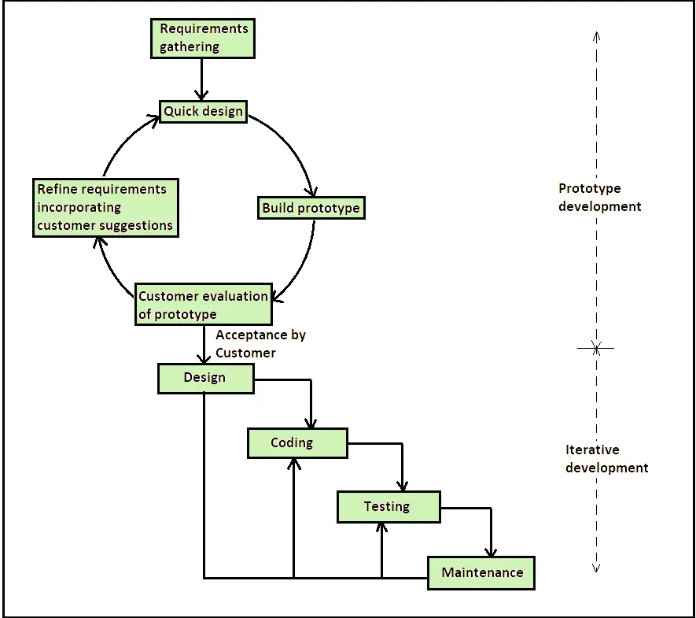
Figure 3.1: Prototype Model Methodology
Figure 3.1 shows the Prototype Development Methodology used in this project. The methodology has five phases, which are Requirement Gathering, Quick Design, Prototype Development, prototype testing and refinement. First, requirements are collected from articles and user needs. Next, the basic layout and interface are designed. After that, the prototype is developed using Figma. The prototype is then checked in the evaluation phase to see if it meets user needs. Finally, changes are made based on feedback to improve the design. This methodology is suitable for this project because it allows the prototype to be improved step by step before it is finalized.

3.2.1 Requirement Gathering
During this phase, information related to KTM passenger problems and transportation services was collected from journals, articles and online resources. User requirements such as real-time train tracking, crowd monitoring and online ticket booking were identified.

3.2.2 Quick Design
A preliminary design was created to visualize the system structure and user interface. Wireframes and screen layouts were prepared to represent the key features of the Smart KTM application.

3.2.3 Prototype Development
The prototype was developed using Figma. Various interfaces such as login pages, train tracking maps, crowd monitoring displays and ticket booking screens were created. Interactive navigation and animations were also added.

3.2.4 User Evaluation
The prototype was evaluated to ensure that navigation, interface consistency and usability met user expectations. Feedback was collected and improvements were made where necessary.

3.2.5 Refinement
Based on user feedback, the prototype was refined and enhanced to improve functionality, interface design and overall user experience.

3.3 Development Tools and Techniques
Figma was used as the primary tool for designing and developing the Smart KTM Malaysia mobile application prototype. The software provides various features for creating user interfaces, wireframes, interactive navigation, and high-fidelity prototypes.
Several design techniques were applied during the development process, including wireframing, interface prototyping and user-centered design principles. Interactive components such as train tracking maps, crowd monitoring displays, and online ticket booking interfaces were created to simulate a realistic mobile application experience.
The use of Figma enabled efficient design iteration and prototype refinement based on usability considerations and project requirements.

CHAPTER 4

SYSTEM DESIGN AND DEVELOPMENT

4.1 Introduction
This chapter explains the system design and development of the Smart KTM Malaysia Mobile Application Prototype. It describes how the proposed system is designed and organized before the prototype is developed. The purpose of this chapter is to provide a clear understanding of how the application works and how users interact with its main functions.
System design is important because it helps organize the system functions in a clear and logical manner. By using different diagrams, the developer can understand the workflow, user interactions and navigation of the application. This process also helps reduce design errors and ensures that the prototype meets the project requirements.
This chapter presents the use case diagram, system flowchart, navigation flow and user interface design of the proposed application. These designs provide a clear overview of the system before moving to the testing and evaluation phase in the next chapter.

4.2 Use Case Diagram
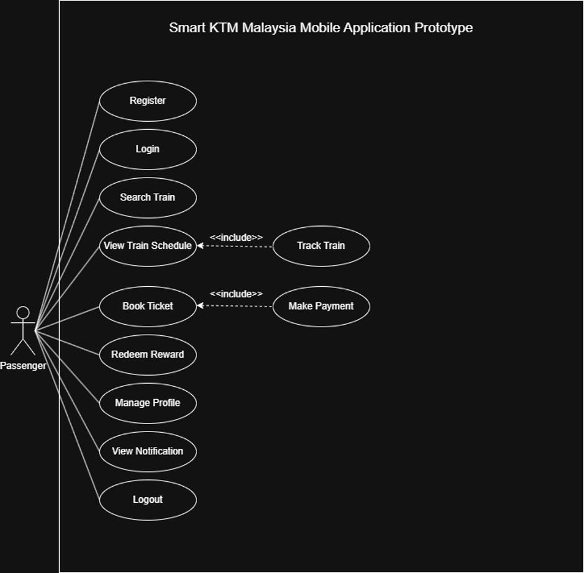

Figure 4.1: Use Case Diagram
Figure 4.1 shows the use case diagram for the Smart KTM Malaysia Mobile Application Prototype, documenting the interaction between the passenger and the proposed system. Full access to the system functions is granted to the passenger after a new account is registered, verified and logged into the system.
Various features are accessible post-login, such as searching for train schedules, viewing real time train tracking, booking tickets, making payments and accessing digital QR tickets. Furthermore, food, coffee or tickets voucher can be redeemed through the Rewards section.
User profiles can be managed within the Profile section, which supports viewing travel history, saving routes, updating payment methods, adjusting notification settings and accessing Help and Support or About KTM information. The integration of these features ensures a highly efficient and customized passenger experience.
In summary, the diagram outlines the main functions of the prototype and clarifies the precise operational paths required to complete various activities within the system.

4.3 System Flowchart
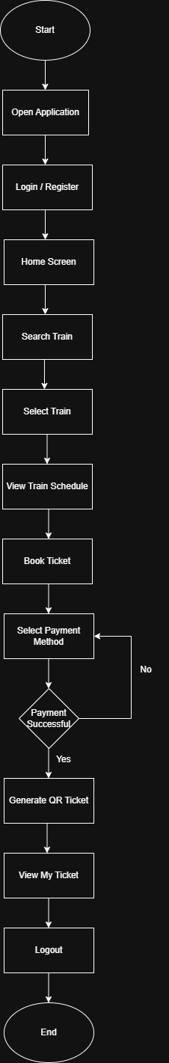

Figure 4.2: System Flowchart
Figure 4.2 presents the system flowchart of the Smart KTM Malaysia Mobile Application Prototype, demonstrating the sequential process of train searching, booking and ticket generation. Access to the Home Screen is granted following account registration or login verification. Subsequently, a train route is specified, a train is selected and the booking details are processed prior to payment method selection.
A critical decision node verifies the success of the payment. If confirmed, a digital QR code ticket is generated and deposited into the My Ticket section for future verification. In the event of a payment failure, the session is redirected back to the payment interface to initiate a retry.
Following completion of the booking loop, the Home Screen becomes accessible once more, permitting the exploration of other system modules, including train tracking, reward, travel history, saved routes and profile configurations. In short, the flowchart summarizes the main architecture of the prototype’s primary user journey, from initial authentication to final ticket issuance.

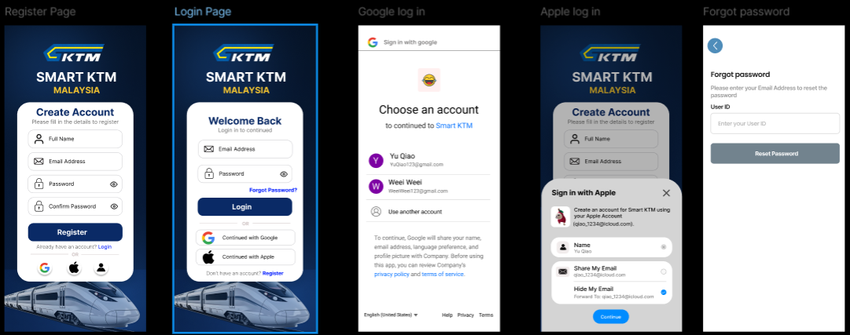
4.4 User Interface Design
Figure 4.3: Login and Registration Interface
Figure 4.3 presents the user authentication interface design of the Smart KTM Malaysia Mobile Application Prototype. This module includes the Register Page, Login Page, Google Sign In, Apple Sign in and Forgot Password Page. These interfaces are designed to provide users with secure and convenient access to the application before using its main features.
The Register Page allow new users to create an account by entering their personal information, while the Login Page enables existing users to access the application using their registered email address and password. To improve convenience, users can also authenticate using their Google or Apple accounts without creating a separate account. In addition, the Forgot Password feature allows users to reset their password if they forget their login credentials.
The authentication interfaces use a consistent blue and white colour scheme, clear input fields and large action buttons to improve readability and usability. This design provides a simple, secure and user-friendly login experience for KTM passengers.

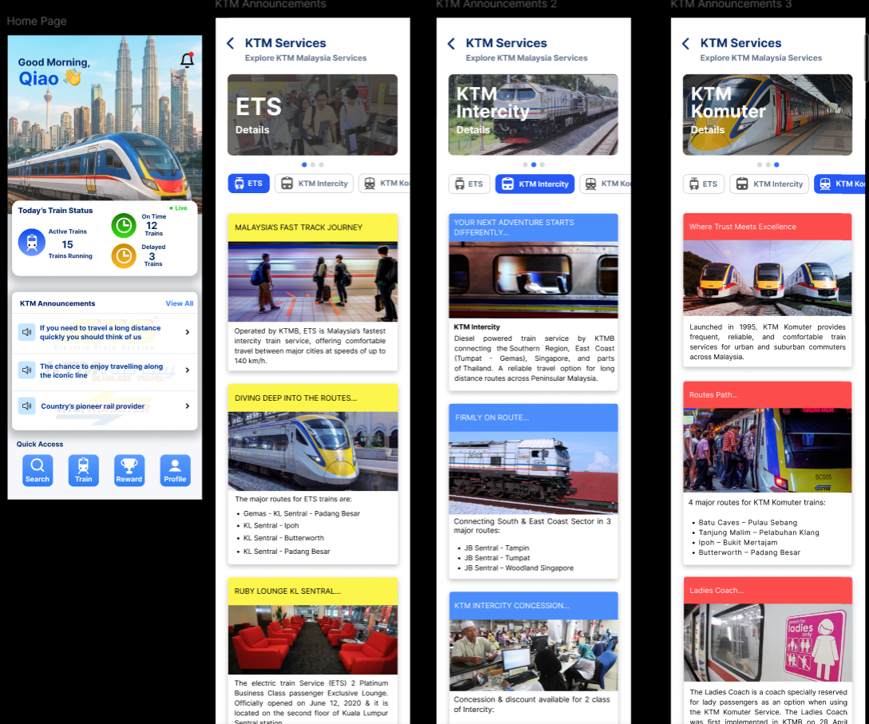
Figure 4.4: Home Interface Design Page
Figure 4.4 presents the home interface design of the Smart KTM Malaysia Mobile Application Prototype. The Home Page serves as the main dashboard of the application after the user successfully logs in. it displays the current train status, including the number of active trains, on-time services, delayed trains and the latest KTM announcements. A quick access menu is also provided at the bottom of the screen, allowing users to easily navigate to the Search, Train Tracking, Rewards and Profile modules.
The Home Module also includes the KTM Services section, where users can explore information about the three main KTM train services like ETS, KTM Intercity and KTM Komuter. Each service page provides relevant information, including service description, operating routes, train features and travel related information. This enables users to better understand the available train services before planning their journey.
The interface adopts a clean blue and white colour theme to maintain consistency throughout the application. Card based layouts, large images and clearly labelled navigation buttons improve readability and provide a simple, user friendly experience for passengers when accessing KTM information and services.

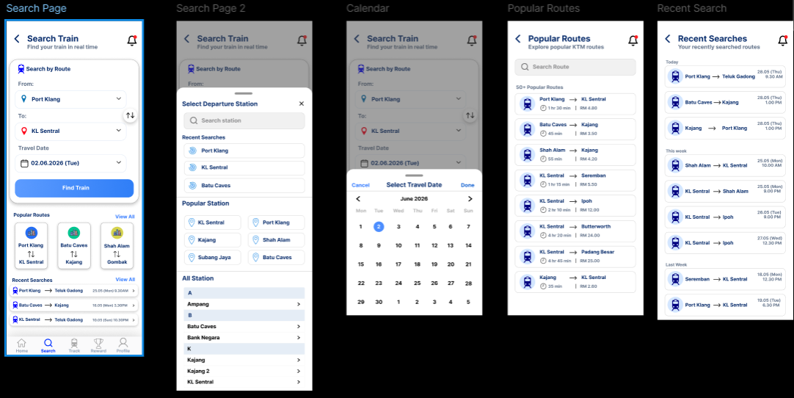
Figure 4.5: Train Search Interface Design
Figure 4.5 presents the train search interface design of the Smart KTM Malaysia Mobile Application Prototype. This module enables users to search for available train services by selecting the departure station, destination station and travel date. The search interface is designed with dropdown menus and a calendar picker to simplify the train booking process and reduce user input errors.
The module also includes several supporting features to improve the user experience. Users can browse Popular Routes for frequently travelled destinations or select routes form the Recent Searches list to perform faster searches. In addition, the station selection page provides a searchable station list, allowing users to quickly locate and choose their preferred departure or arrival station.
The train search interface follows a clean and consistent blue and white design with clearly labelled input fields, intuitive icons and simple navigation. These design elements improve usability and enable passengers to search for train routes efficiently before proceeding to the ticket booking process.

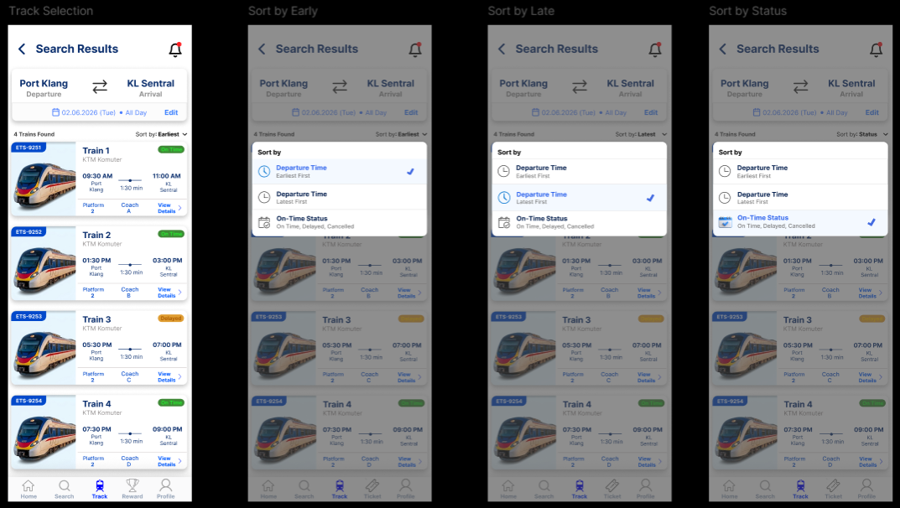
Figure 4.6 presents the train search results interface design of the Smart KTM Malaysia Mobile Application Prototype. After users enter the departure station, destination station and travel date, the system displays a list of available train services. Each train card provides important travel information, including the train number, departure time and arrival times, travel duration, platform number, coach number and current service status. Users can also select View Details to obtain more information before proceeding with the ticket booking process.
Figure 4.6: Train Search Results Interface Design
To improve the user experience, the application provides several sorting options. Users can sort the train list by Earliest Departure Time, Latest Departure Time or Train Status. These sorting features help passengers quickly find the train service that best matches their travel preferences and schedule.
The interface adopts a clean card-based layout with a consistent blue and white colour theme to improve readability and usability. Clear labels, train images and status indicators allow users to compare different train services easily and make informed travel decisions.

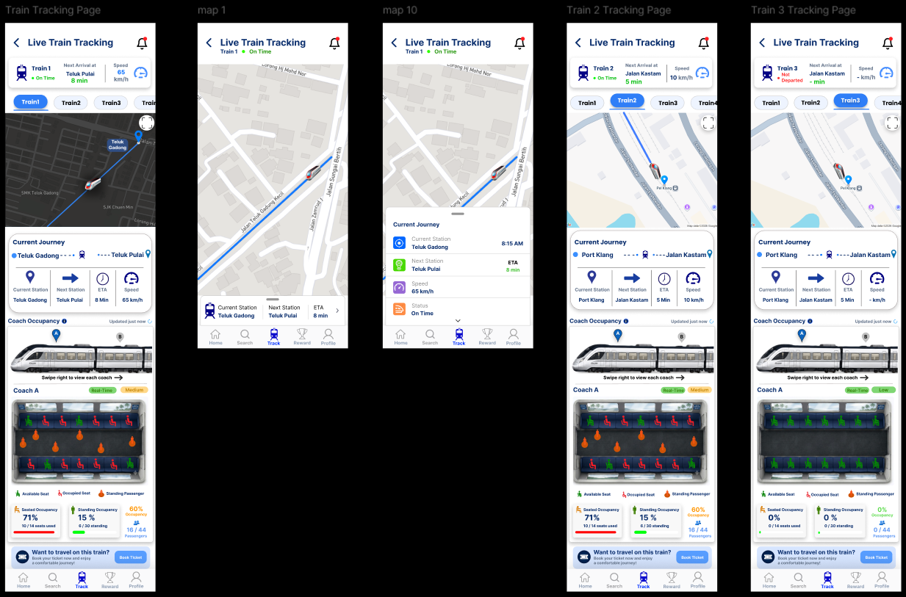
Figure 4.7 presents the live train tracking interface design of Smart KTM Malaysia Mobile Application Prototype. This module enables passengers to monitor the real time location of KTM trains through an interactive map. Users can select different trains to view their current position, travelling speed, estimated arrival time, next station and operational status. The interactive map allows users to follow the train’s movement and better estimate its arrival time.
Figure 4.7: Live Train Tracking Interface Design
In addition to real time train tracking, the module provides detailed journey information, including the current station, next station, train speed, estimated arrival time and service status. This application also displays coach occupancy information by indicating the number of available seats, occupied seats and standing passengers in each coach. This feature helps passengers identify less crowded coaches before boarding, improving travel comfort and reducing congestion during peak hours.
The interface is designed using a clean blue and white colour scheme with an interactive map, information cards and graphical occupancy indicators to improve readability and user experience. Different train selections allow users to monitor multiple train services, while the clear layout enables passengers to quickly access real time travel information and make informed travel decisions.

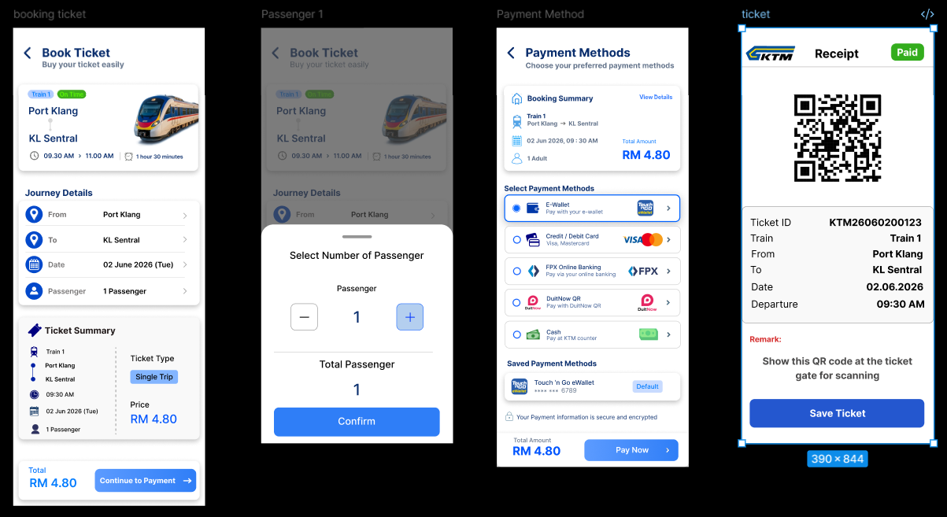
Figure 4.8: Ticket Booking Interface Design
Figure 4.8 presents the ticket booking interface design of the Smart KTM Malaysia Mobile Application Prototype. This module guides users through the complete ticket purchasing process, beginning with the booking page where passengers can review their journey details, including the departure station, destination, travel date, departure time, ticket type and ticket price. Users can also select the number of passengers before proceeding to the payment stage.
After confirming the booking details, users are directed to the Payment Method page, where they can choose their preferred payment option such as Touch ‘n Go eWallet, Credit or Debit Card, FPX Online Banking, DuitNow QR or Cash. This application also displays a booking summary and the total amount payable, allowing users to verify their information before completing the transaction.
Once the payment is successfully completed, the system automatically generates a QR code ticket containing the ticket ID, train information, travel route, travel date, departure time and payment status. The QR code can be presented at the station entrance for ticket verification and boarding. The interface follows a clean and consistent blue and white colour theme with clearly organized information cards, large action buttons and simple navigation, providing passengers with a secure and user-friendly ticket booking experience.

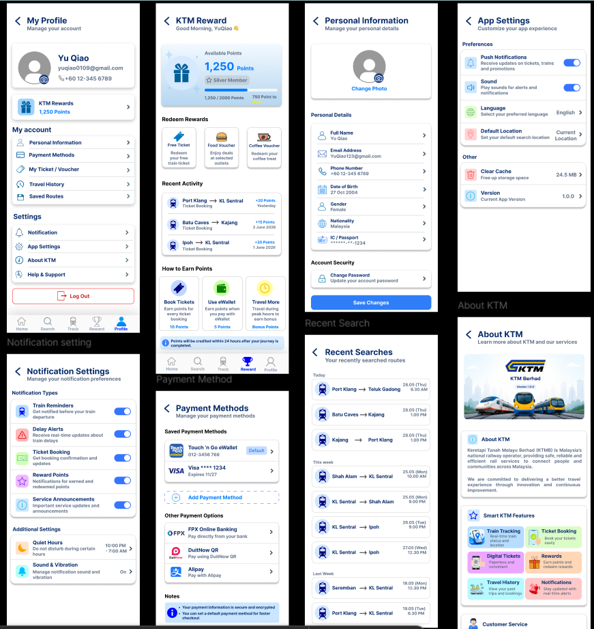
Figure 4.9: Account Management Interface Design
Figure 4.9 presents the account management interface design of the Smart KTM Malaysia Mobile Application Prototype. This module allows users to manage their personal information and customise the application according to their preferences. The My Profile page serves as the main dashboard, providing quick access to personal information, payment methods, travel history, saved routes, notification settings, application settings, Help & Support, About KTM and logout functions.
The module also includes several supporting interfaces to enhance the user experience. Users can update their personal information, managed saved payment methods, view recent travel searches and configure notification settings preferences such as train reminders, delayed alerts, ticket booking confirmations, reward notifications and service announcements. In addition, the KTM Reward page enables users to check their reward points, redeem vouchers and review their recent reward activities. The About KTM page provides background information about KTM Berhad together with the key features available in the application.
The account management interfaces follow a consistent blue and white colour scheme with simple navigation menus, information cards and clearly labelled icons. This design improves readability, enhances accessibility and enables users to manage their account information and application settings efficiently through a user-friendly interface.

4.5 Conclusion
In conclusion, this chapter has described the system design and development of the Smart KTM Malaysia Mobile Application Prototype. The use case diagram, system flowchart and user interface design were presented to explain the overall structure and functionality of the application. These designs provide a clear guideline for developing the proposed system and ensure that the application meets the project objectives. The next chapter presents the prototype of the application and explains its main features.

CHAPTER 5

PROTOTYPE

5.1 Introduction
This chapter presents the prototype of the Smart KTM Malaysia Mobile Application developed based on the system design discussed in the previous chapter. The prototype was created using Figma to demonstrate the appearance and functionality of the proposed mobile application before actual system implementation.
The prototype illustrates how users interact with different modules of the application through a series of user interface screens. It includes the authentication module, home module, train search module, live train tracking module, ticket booking module and account management module. Each module demonstrates the expected workflow and user interaction when using the application.
The purpose of this chapter is to provide a clear visualization of the proposed system and verify that all planned features are included in the application design. The completed prototype also serves as the basis for the testing and evaluation activities presented in the following chapter.

5.2 Authentication Prototype
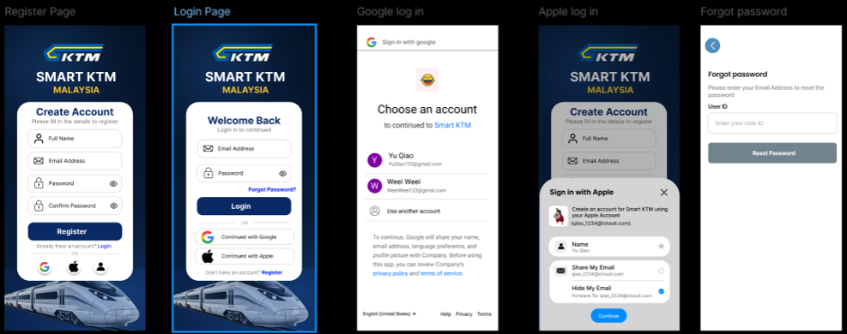
Figure 5.1: Login and Registration Interface Design
Figure 5.1 shows the authentication prototype of the Smart KTM Malaysia Mobile Application. When users first open this application, they are presented with the authentication module, which provides options to register a new account or log in using existing credentials. New users are required to enter their full name, email address and password to create an account, while existing users can sign in using their registered email address and password to access the application.
To provide a more convenient login experience, the application supports Google Sign-In and Apple Sign-In, allowing users to authenticate their accounts quickly without completing the registration process manually. If users forget their password, they can access the Forgot Password page and reset their password by entering their registered email address before logging in again.
After successful authentication, users are redirected to the Home Page, where they can begin using the application’s main functions, such as searching for train services, tracking train locations, booking tickets and managing their personal account. The authentication prototype demonstrates the complete login process and ensures that only authorised users can access the system securely.

5.3 Home Page Prototype
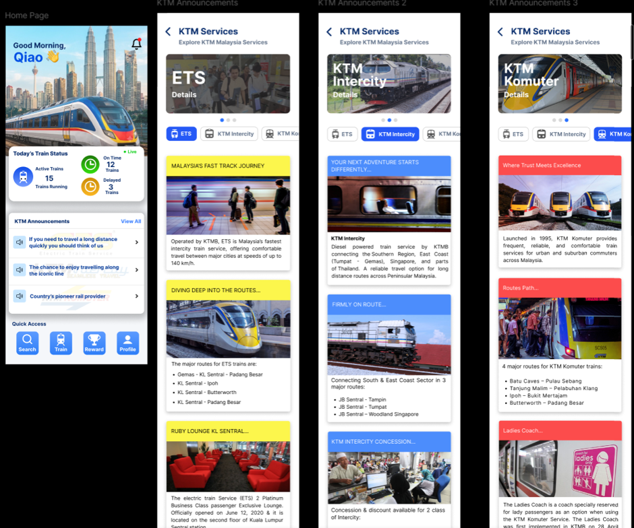
Figure 5.2: Home Page Interface Design
Figure 5.3 shows the Home Page prototype of the Smart KTM Malaysia Mobile Application. After users successfully log in, they are directed to the Home Page, which acts as the starting point for accessing the application’s main features. The interface displays important railway information, including today’s train status, active train services, delayed trains and the latest announcements from KTM Berhad. This allows passengers to stay updated with current railway operations before planning their journey.
The Home Page also provides direct access to the application’s core functions through the bottom navigation bar. Users can quickly navigation to the Train Search, Live Train Tracking, Rewards and Profile modules without returning to previous pages. In addition, the KTM Services section introduces the three railway services offered by KTM Berhad, namely ETS, KTM Intercity and KTM Komuter. Each service page provides useful information to help passengers understand the available train options and select the most suitable service for their travel needs.
Overall, the Home Page prototype is designed to provide passengers with quick access to important travel information and application features in a single interface. The simple layout and organised navigation help users perform their tasks effectively while improving the overall travel planning experience.

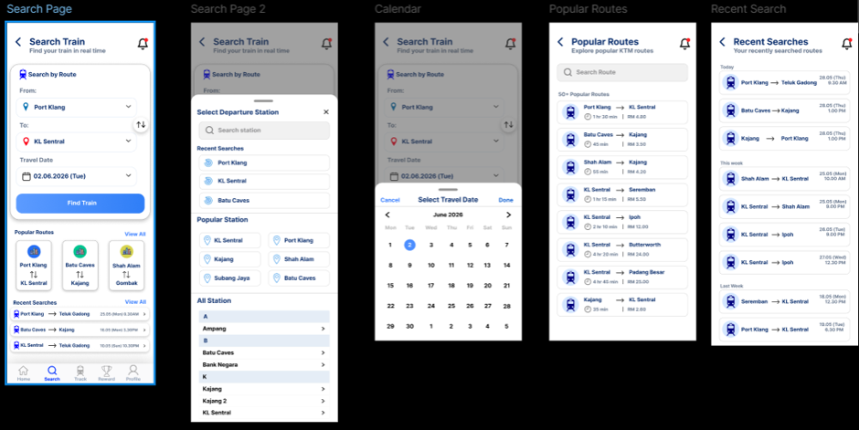
5.4 Train Search Page Prototype
Figure 5.3: Train Search Interface Design
Figure 5.3 shows the train search prototype of the Smart KTM Malaysia Mobile Application. After accessing the Home Page, users can open the Train Search module to search for available train services. The search process begins by selecting the departure station, destination station and preferred travel date. The application also provides a calendar feature to help users choose their desired travel date easily.
To make the searching process more efficient, the prototype includes Popular Routes and Recent Searches. Routes allow users to quickly select frequently travelled destinations without entering the route manually, while Recent Searches display previously searched routes for faster access. In addition, users can browse or search the station list when selecting their departure and destination stations.
Once all required information has been entered, users can tap the Search Train button to display the available train services. The application then directs users to the Train Search Results page, where they can compare different train schedules and continue with the ticket booking process.

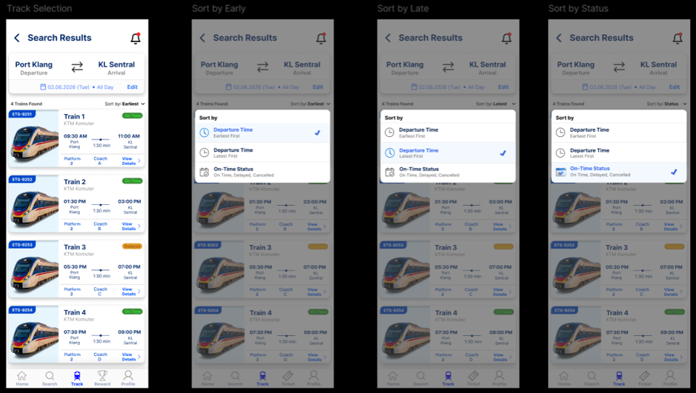
5.5 Train Search Result Page Prototype
Figure 5.4: Train Search Results Interface Design
Figure 5.4 presents the train search results prototype of the Smart KTM Malaysia Mobile Application. After users complete a train search, the application displays a list of available train services based on the selected route and travel date. Each train card shows important travel information such as the train number, departure time, arrival time, travel duration, platform number, coach number and current service status.
To help users find the most suitable train service, the application provides several sorting options. Users can sort the results by Earliest Departure, Latest Departure or Train Status according to their travel preferences. This feature allows passengers to compare different train schedules more conveniently before making a booking decision.
After reviewing the available train services, users can select their preferred train by tapping the View Details button. The application then proceeds to the ticket booking page, where users can review their journey information and continue with the booking process.

5.6 Live Train Tracking Page Prototype
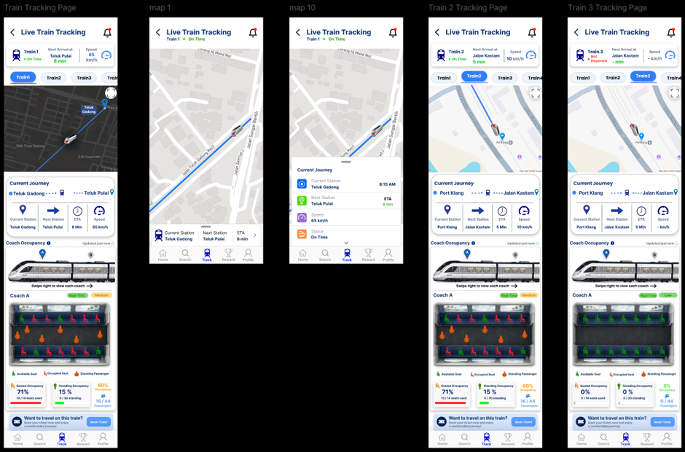
Figure 5.5: Live Train Tracking Interface Design
Figure 5.5 shows the live tracking prototype of the Smart KTM Malaysia Mobile Application. After selecting a train form the search results, users are directed to the Live Train Tracking page. This module allows passengers to monitor the selected train in real time through an interactive map. The application displays important journey information, including the train’s current location, current station, next station, travelling speed, estimated arrival time and operational status. These details help passengers keep track of the train’s progress before reaching their boarding station.
The prototype also allows users to switch between different train services by selecting Train 1, Train 2 or Train 3. Once a different train is selected, the map and journey information are automatically updated to display the real time status of the selected service. This feature enables passengers to monitor multiple train services conveniently within a single module.
Another key feature of this prototype is the coach occupancy information. The application provides a visual overview of each coach by showing the number of available seats, occupied seats, standing passengers and the overall occupancy percentage. Users can swipe between different coaches to compare crowd levels before boarding. By providing real time train tracking together with coach occupancy information, the prototype helps passengers plan their journey more effectively and choose a less crowded coach for a more comfortable travel experience.

5.7 Ticket Booking Page Prototype
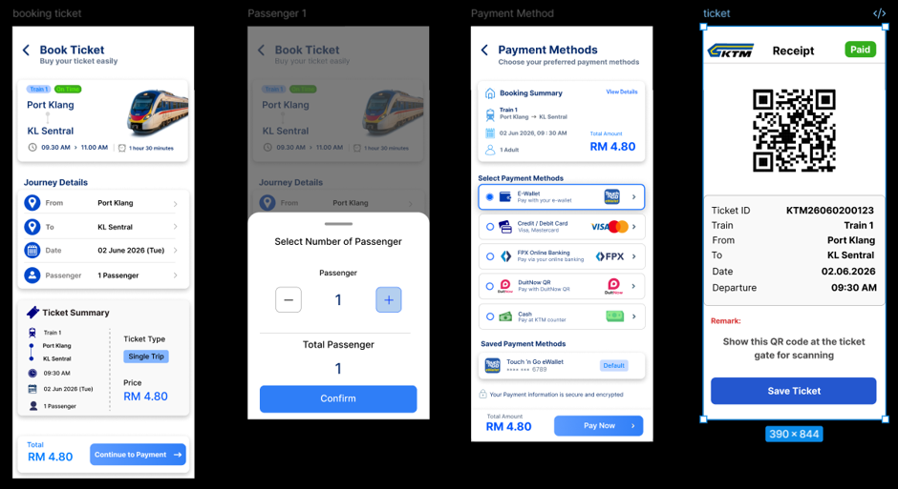
Figure 5.6: Ticket Booking Interface Design
Figure 5.6 shows the ticket booking prototype of the Smart KTM Malaysia Mobile Application. After selecting a preferred train from the search results, users are directed to the Book Ticket page. The application displays the selected train information, including the departure station, destination, departure time, arrival time, travel duration and ticket price. Users can review the journey details before proceeding with the booking process.
Next, users are required to select the number of passengers for the journey. Once the passenger information has been confirmed, the application calculates the total ticket price automatically and directs users to the payment page. The payment prototype supports multiple payment methods, including Touch ‘n Go eWallet, Credit or Debit Card, FPX Online Booking, DuitNow QR and Cah, allowing users to choose the payment option that best suits their preference.
After the payment is successfully completed, the application generates a digital ticket with a unique QR code. The ticket contains important travel information such as the ticket ID, train number, departure station, destination, travel date and departure time. Passengers can save the digital ticket on their mobile device and present the QR code at the station entrance for ticket verification and boarding. This prototype demonstrates the complete ticket booking process from journey confirmation to successful completion ticket generation, providing users with a fast and convenient ticket purchasing experience.

5.8 Account Management Page Prototype
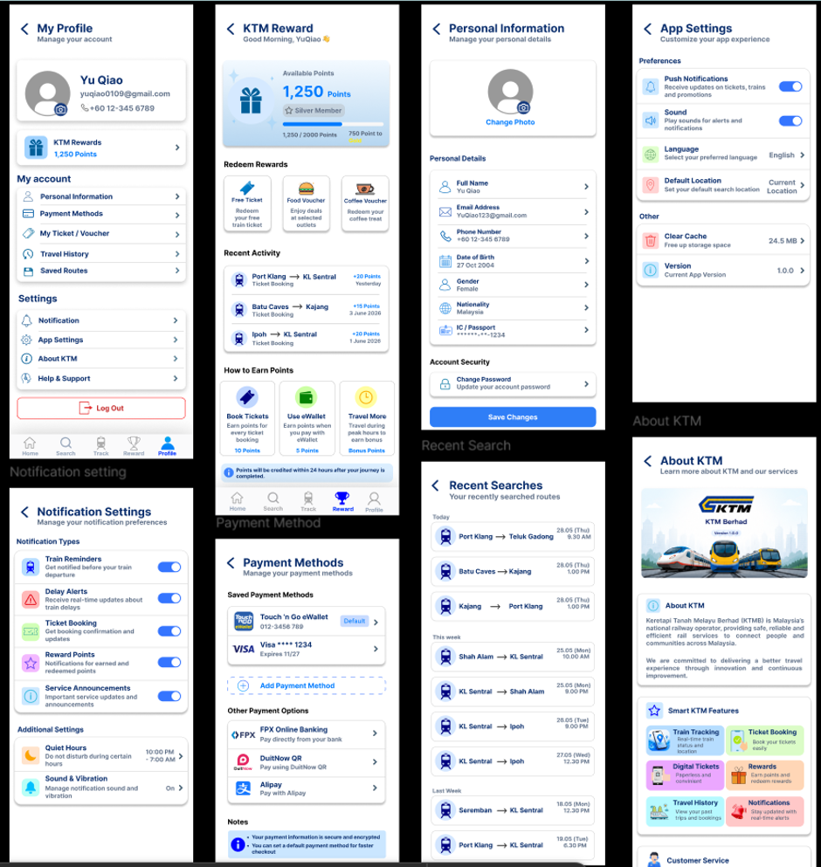
Figure 5.7: Account Management Interface Design
Figure 5.7 shows the account management prototype of the Smart KTM Malaysia Mobile Application. Users can access this module by selecting the Profile icon from the bottom navigation bar. The profile page acts as the main account centre, allowing users to view and manage their personal information, payment methods, travel history, saved routes, application settings, notification settings and other account related features from a single location.
The prototype also includes the KTM Rewards page, where users can check their available reward points, redeem rewards and view their recent reward activities. Through the Personal Information page, users are able to update their profile details such as their name, email address, phone number, date of birth, nationality and account password. The Payment Methods page allows users to manage their preferred payment options for future ticket purchases, while the Recent Searches page stores previously searched routes for quicker access.
In addition, users can customize the application through the Notification Settings and App Settings pages by enabling or disabling train reminders, delay alerts, sound notifications and language preferences. The module also includes the About KTM page, which provides background information about KTM Berhad and introduces the main features available in the Smart KTM Malaysia Mobile Application. Overall, this prototype allows users to personalise the application, manage their account efficiently and improve their overall travel experience.

5.9 Conclusion
In conclusion, this chapter has presented the complete prototype of the Smart KTM Malaysia Mobile Application developed using Figma. The prototype demonstrates the overall workflow of the application, beginning from user authentication to train searching, live train tracking, ticket booking, reward management and account management. Each prototype screen provides a clear representation of how users interact with the application and completely different tasks during their journey.
The completed prototype serves as a visual model of the proposed system and verifies that all planned features have been successfully incorporated into the application. It also allows the developer to review the system flow and identify possible improvements before implementation. Overall, the prototype supports the project objectives by providing a simple, organized and user-friendly mobile application for KTM passengers. The next chapter presents the testing and evaluation process, including functional testing, user acceptance testing and questionnaire analysis, to determine whether the application performs according to the system requirements.

CHAPTER 6

TESTING AND EVALUATION

6.1 Introduction
This chapter presents the testing and evaluation of the Smart KTM Malaysia Mobile Application Prototype. After completing the system design and prototype development, prototype testing was conducted to ensure that the application functions correctly and meets the project objectives. The purpose of the testing process is to verify that the proposed features, navigation flow and user interactions operate as expected while providing a satisfactory user experience.
Prototype testing was carried out to evaluate the main features of the application, including user authentication, train search, live train tracking, ticket booking, payment method selection, QR ticket generation, reward management and account management. Each prototype function was tested to ensure that the users could navigate between screens smoothly and that all interactions worked according to the proposed system design.
In addition, User Acceptance Testing was conducted by inviting several respondents to evaluate the prototype. After using the application, the respondents completed a questionnaire to provide feedback on the usability, functionality, interface design and overall satisfaction of the system. The results obtained from the testing and questionnaire are analysed in this chapter to determine whether the proposed application successfully meets user requirements and project objectives.

6.2 Prototype Testing Evaluation
Prototype testing was conducted to verify that the Smart KTM Malaysia Mobile Application Prototype functions correctly according to the proposed system design. The purpose of this testing was to ensure that all prototype screens, navigation flows and interactive elements operate as expected before the prototype was evaluated by users. This process also helps identify any navigation issues or inconsistencies that could affect the overall user experience.
During the testing process, all major modules of the application were examined individually. The functions tested included user registration, user login, train search, live train tracking, coach occupancy, ticket booking, payment method selection, QR ticket generation, notification settings and profile viewing. Each function was tested by following the expected user workflow to ensure that users could navigate smoothly between screens and complete each task without confusion.
The prototype testing results are presented through a series of screenshot to summarize all prototype test cases performed during the evaluation. Each test case includes the use case, function, testing scenario, test data, expected results, actual results, testing status and remarks. Based on the testing results, all prototype functions performed successfully and the actual results matched the expected results. No major navigation or functional issues were identified during testing. Therefore, the Smart KTM Malaysia Mobile Application Prototype was considered suitable for the next stage of evaluation, namely the User Acceptance Testing conducted with selected respondents.

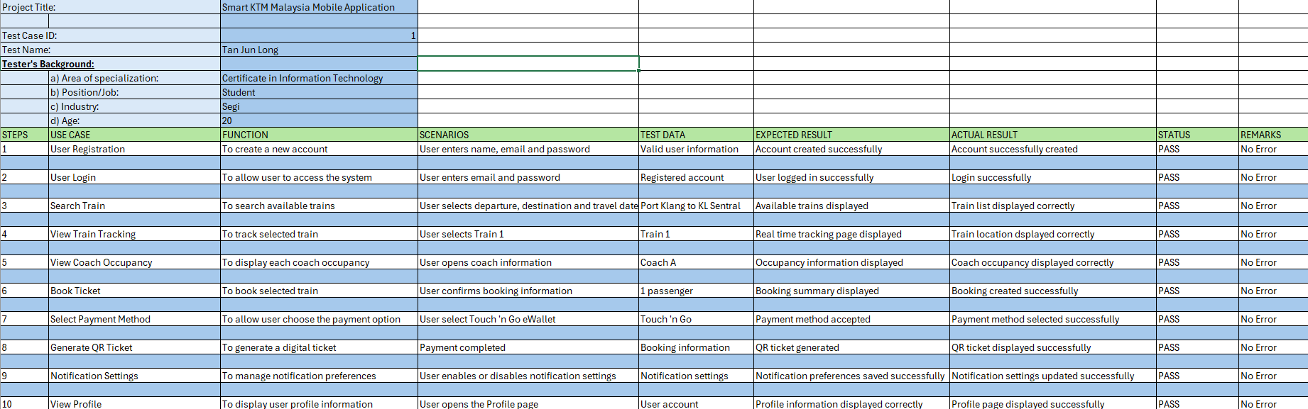
6.2.1 Prototype Testing Result
Figure 6.1: Prototype Testing Result
Figure 6.1 presents the prototype testing results of the Smart KTM Malaysia Mobile Application. A total of ten functional test cases were performed to evaluate the major features of the prototype. Each test case compares the expected result with the actual result after the testing process.
Based on the results, all test cases achieved a PASS status. The registration and login modules successfully allowed users to access the application. The train search and live train tracking modules displayed the correct train information according to the selected route.
In addition, the ticket booking process, payment method selection and QR ticket generation functions operated correctly without any errors. The notification settings and profile management modules were also successfully tested and functioned as expected.
Overall, the prototype testing demonstrates that the Smart KTM Malaysia Mobile Application Prototype operates according to the proposed design and is ready for user evaluation.

6.3 User Testing Evaluation
User testing was conducted to evaluate the usability and effectiveness of the Smart KTM Malaysia Mobile Application Prototype. A total of 10 respondents participated in the testing process by interacting with the prototype developed using Figma. The respondents were asked to perform several common tasks, including user registration, logging in, searching for trains, viewing live train tracking, checking coach occupancy, booking tickets, selecting a payment method, generation a QR ticket, managing notification settings and viewing profile information.
After completing the testing session, the respondents answered an online questionnaire using Google Forms. The questionnaire was designed to collect feedback on the usability, functionality, navigation, interface design and overall user satisfaction of the prototype. The responses were analyzed using charts and percentages generated by Google Forms to identify users’ opinions and evaluate whether the prototype met their expectations.
Overall, the feedback collected from the respondents was positive. Most participants agreed that the prototype was easy to use, the interface was clear and attractive and the navigation between pages was smooth. The train search, live train tracking, ticket booking, QR ticket generation and notification features were considered useful and easy to understand. The questionnaire results indicate that the Smart KTM Malaysia Mobile Application Prototype successfully provides a user-friendly experience and achieves its intended objectives.

6.3.1 Questionnaire Results
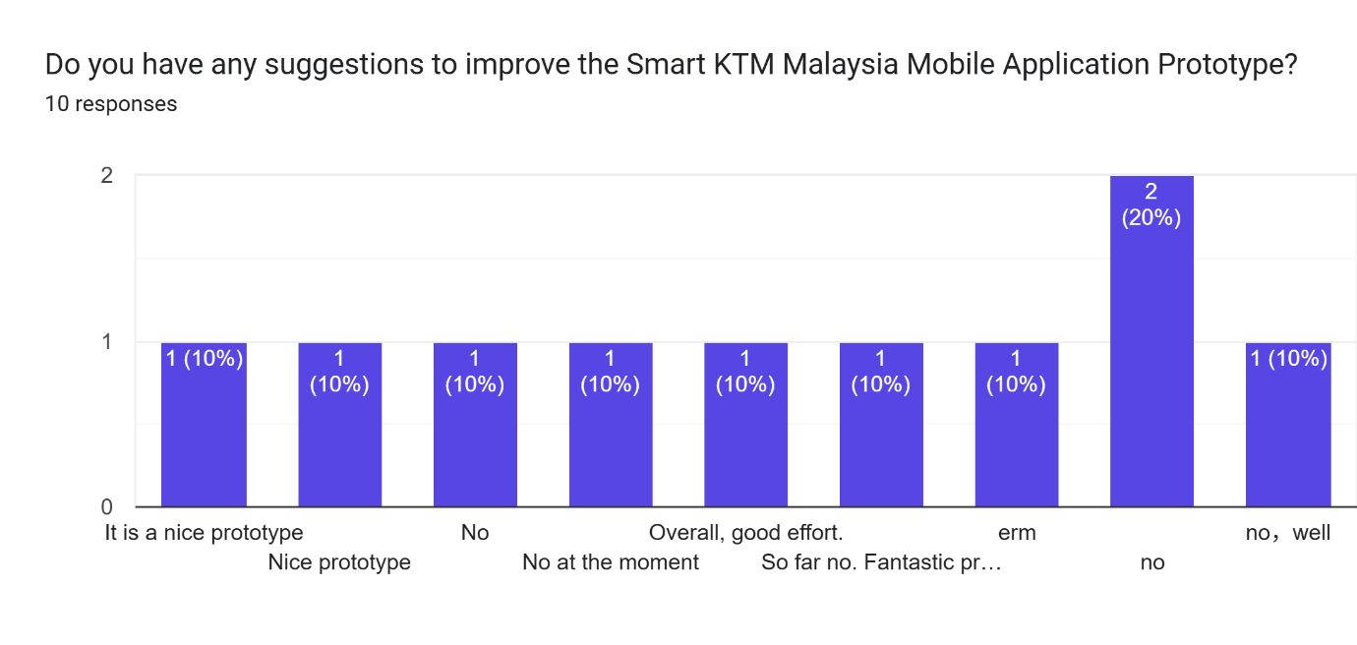
Figure 6.2: Questionnaire Results
Figure 6.2 presents the respondents’ suggestions for improving the Smart KTM Malaysia Mobile Application Prototype. The results show that most respondents did not provide any major suggestions for improvement. Several respondents answered “No”, “No at the moment” or similar responses, indicating that they were generally satisfied with the prototype.
Some respondents also gave positive comments such as “it is a nice prototype”, “Nice prototype”, “Overall, good effort” and “Fantastic prototype”. These responses indicate that the prototype is user-friendly and meets the expectations of most respondents.
Overall, the feedback suggests that the Smart KTM Malaysia Mobile Application Prototype provides a satisfactory user experience. Although only a few respondents offered additional comments, the overall responses indicate that the prototype has achieved its intended objectives and requires only minor improvements in future development.

6.4 Evaluation Based on Project Objectives
The evaluation of the Smart KTM Malaysia Mobile Application Prototype was conducted based on the three objectives established at the beginning of the project. The prototype testing and user testing results were analyses to determine whether the proposed application successfully achieved its intended objectives.
Objective 1
The first objective was to implement a Smart KTM Passenger Monitoring System that can estimate the number of passengers in each coach using pressure sensors. Based on the prototype testing, the coach occupancy feature was successfully displayed and allowed users to view the estimated occupancy level of each coach. The user testing results also indicated that most respondents agreed that the coach occupancy information was clear and useful for selecting a less crowded coach. Therefore, the first objective was successfully achieved.
Objective 2
The second objective was to design a live train tracking feature that displays the current location of the train through a map interface. The prototype testing confirmed that the live train tracking page displayed the train location correctly together with journey information such as the current station, next station, estimated arrival time and train status. The questionnaire results also showed that respondents found the tracking feature easy to use and helpful for monitoring train movements. Therefore, the second objective was successfully achieved.
Objective 3
The third objective was to implement an online ticket booking feature for KTM services through a mobile application. During prototype testing, the ticket booking process, payment method selection and QR ticket generation functioned successfully without any major issues. User testing also showed that respondents agreed the booking process was simple, convenient and easy to understand. The digital QR ticket was considered useful for reducing manual ticket collection and improving travel convenience. Therefore, the third objective was successfully achieved.

6.5 System Strengths and Limitations
The Smart KTM Malaysia Mobile Application Prototype has several strengths as well as some limitations. The evaluation of these strengths and limitations helps identify the effectiveness of the proposed prototype and provides recommendations for future improvements.

6.5.1 System Strengths
One of the main strengths of the Smart KTM Malaysia Mobile Application Prototype is its user-friendly interface. The application adopts a clean and consistent blue and white color scheme, making it easy for users to understand the navigation and access different functions. The simple layout and clearly labelled buttons help improve the overall user experience.
Another strength is the live train tracking feature, which allows users to view the train’s current location through a map interface. This feature enables passengers to monitor train movements, estimate arrival times and plan their journeys more efficiently.
In addition, the prototype includes an online ticket booking system that allows users to search for train schedules, select their preferred train, make payments and generate a QR ticket for boarding. The coach occupancy feature also helps passengers choose a less crowded coach, providing a more comfortable travel experience.

6.5.2 System Limitations
Although the Smart KTM Malaysia Mobile Application Prototype demonstrates the proposed functions successfully, several limitations still exist. Firstly, the application is currently developed as a prototype using Figma, which means the functions are only simulated and are not connected to a real KTM database or live operating system.
Secondly, the live train tracking and coach occupancy information are based on prototype demonstrations and do not display real time data from actual GPS devices or passenger sensors. Therefore, the information shown in the prototype is for demonstration purposes only.
Finally, the online payment and QR ticket generation are also simulated within the prototype. The application is not integrated with actual payment gateways or KTM ticketing systems. These features would require further development and integration before the application can be deployed for real world use.

6.6 Conclusion
This chapter presented the testing and evaluation of the Smart KTM Malaysia Mobile Application Prototype. Prototype testing was conducted to verify that all the main functions operate according to the proposed system design. The testing results showed that the major features, including user authentication, train search, live train tracking, coach occupancy, online ticket booking, payment method selection, QR ticket generation, notification settings and profile management, functioned successfully without major issues.
User testing was also carried out to evaluate the usability and effectiveness of the prototype. The questionnaire results indicate that most respondents were satisfied with the overall design, functionality and ease of use of the application. The respondents agreed that the live train tracking, coach occupancy information and online ticket booking features were useful and could improve the overall KTM travel experience.
Based on the prototype testing and user evaluation, the Smart KTM Malaysia Mobile Application Prototype successfully achieved the proposed project objectives. Although the application is currently limited to a prototype and does not use real time KTM data or actual sensor integration, it demonstrates the feasibility of the proposed solution and provides a strong foundation for future development and implementation.

CHAPTER 7

CONCLUSION AND RECOMMENDATIONS

7.1 Introduction
This chapter presents the overall conclusion and recommendations for the Smart KTM Malaysia Mobile Application Prototype. It summarizes the achievements of the project based on the objectives, system design, prototype development and testing results discussed in the previous chapters. The purpose of this chapter is to evaluate the overall success of the proposed prototype and determine whether it meets the intended user requirements.
In addition, this chapter discusses several recommendations for future improvements. Although the proposed prototype successfully demonstrates the main features of the application, there are still opportunities to enhance the system by integrating real-time technologies, improving existing functions and adding new features to provide a better user experience for KTM passengers.

7.2 Conclusion
This project successfully developed the Smart KTM Malaysia Mobile Application Prototype to improve the travel experience of KTM passengers. The prototype was designed to provide three main functions, namely passenger monitoring, live train tracking and online ticket booking. These features aim to help passengers obtain train information more conveniently and improve journey planning.
Throughout the project, the Prototype Development Methodology was applied to guide the development process form requirements gathering to prototype evaluation. The system design, user interface, prototype development and testing activities were completed successfully. The prototype testing and user testing results showed that the proposed application is easy to use and most respondents were satisfied with its functionality and interface.
Overall, the Smart KTM Malaysia Mobile Application Prototype successfully achieved all the project objectives. Although the application is currently a prototype and does not integrate with real-time KTM systems or passenger sensors, it demonstrates the feasibility of the proposed solution and provides a strong foundation for future development.

7.3 Future Recommendations
Although the Smart KTM Malaysia Mobile Application Prototype has successfully demonstrated its proposed functions, several improvements can be made in future development to enhance the application’s performance and usability. Firstly, the passenger monitoring feature can be improved by integrating pressure sensors installed in each train coach. This would allow the application to display real-time coach occupancy information instead of simulated data, enabling passengers to choose less crowded coaches more accurately.
Secondly, the live train tracking feature can be enhanced by integrating the application with KTM’s real-time GPS system. This would provide passengers with more accurate train locations, estimated arrival times and delay information. in addition, push notifications can be implemented to inform users immediately about train delays, service disruptions, platform changes or other important announcements, allowing passengers to plan their journeys more efficiently.
Finally, the online ticket booking module can be further developed by connecting the application to KTM’s official ticketing and payment systems. This would enable users to purchase tickets securely using various payment methods, such as online banking, debit or credit cards and digital wallets. Additional features such as multilingual support, travel history, favourite routes, language and AI-based travel recommendations can also be incorporated to improve the overall user experience and make the application more practical for daily KTM passengers.

Reference
- Bachok, S., Osman, M. M., Khalid, U. A., & Ibrahim, M. (2013). Commuters' perceptions
on rail based public transport services: A case study of KTM Komuter in Kuala Lumpur city, Malaysia. Planning Malaysia, 11(3), 99-124.
- Husnina, S. N., Mokhtar, S., Hussein, M. Z. S. M., Hamid, Z. J. M. H., Sinniah, G. K., &
Ghani, N. A. (2022). Factors affecting mobile public transportation applications usage among urban rail transit passengers in Klang Valley, Malaysia. Journal of Computational Science and Intelligent Technologies, 1(1), 1-20.
- K. Ganesh, M. Thrivikraman, J. Kuri, H. Dagale, G. Sudhakar, & S. Sanyal. (2012).
Implementation of a real time passenger information system. arXiv preprint, arXiv:1206.0447.
- Khalid, U. A., Bachok, S., Osman, M. M., & Ibrahim, M. (2014). User perceptions of rail
public transport services in Kuala Lumpur, Malaysia: KTM Komuter. *Procedia - Social and Behavioral Sciences, 153*, 566-573.
- Khor, S. Y., Aruljodey, S., & Shanmugam, K. (2024). Digital challenges to economic
opportunities: Ubiquitous computing in Malaysia's public transportation sector. Journal of Applied Technology and Innovation, 8(2), 1-14.
- Masirin, M. I. M., Salin, A. M., Zainorabidin, A., Martin, D., & Samsuddin, N. (2017).
Review on Malaysian rail transit operation and management system: Issues and solution in integration. IOP Conference Series: Materials Science and Engineering, 226(1), 012029.
- Wahab, S. N., Hamzah, M. I., Suki, N. M., Chong, Y. S., & Kua, C. P. (2025). Unveiling
passenger satisfaction in rail transit through a consumption values perspective. Multimodal Transportation, 4(1), 100196.
- Yusoff, I., Ng, B. K., & Azizan, S. A. (2021). Towards sustainable transport policy
framework: A rail-based transit system in Klang Valley, Malaysia. PLoS ONE, 16(3), e0248519.



Proposal
Student Name: | Chew Jie Weei
Student ID: | SCSJ2500057
Subject Code: | CIT1334
Subject Name: | Integrated Systems
Lecturer Name: | Ts. Umi Kalsum Binti Muhamad
Smart KTM Malaysia Mobile Application

PROJECT TITLE
Smart KTM Malaysia: Real Time Train Tracking and Passenger Monitoring Mobile Application

Table of Contents
1.0 Introduction 3
1.1 Problem Statement 3
2.0 Aim of the Project 4
2.1 Objectives of the Project 4
3.0 Literature Review 5
3.1 Real Time Tracking System 5
3.2 Mobile Transportation Application and User Acceptance 5
3.3 Key Service Quality Issues in Malaysian Rail Transit 6
4.0 Methodology 7
4.1.1 Planning Phase 7
4.1.2 Analysis Phase 7
4.1.3 Design Phase 8
4.1.4 Development Phase 8
4.1.5 Testing Phase 8
4.2 Approach 8
5.0 Project Plan 8
6.0 Conclusion 10
Reference 11

1.0 Introduction
Public transportation plays an important role in Malaysia, as many people rely on train services for daily travel, particularly in urban areas such as Kuala Lumpur and Selangor. KTM Malaysia is one of the main railway transportation providers in the country and is widely used by students, workers, and tourists due to its affordability and accessibility. However, passengers often face several issues when using KTM services, including delays, overcrowded coaches during peak hours, and difficulties in obtaining accurate train information (Khalid et al., 2014).
With the rapid advancement of mobile technology and smart transportation systems, passengers today increasingly expect faster, smarter, and more convenient transportation services through mobile applications (Biyik et al., 2021). Many users prefer to receive real-time information directly on their smartphones rather than relying on station announcements or physical ticket counters. In addition, real-time information systems have been shown to improve transportation efficiency and enhance passenger experience by providing live tracking and estimated arrival times (Ganesh et al., 2012). Furthermore, mobile-based transportation solutions are becoming an essential component of modern smart mobility systems, enabling better communication between service providers and passengers (Husnina et al., 2022).
Therefore, this project proposes the development of a Smart KTM Malaysia mobile application prototype that integrates real-time train tracking, passenger crowd monitoring, and online ticket booking features. The proposed application aims to help users track train locations more efficiently, identify less crowded coaches before boarding, and purchase tickets digitally through their smartphones. In addition, the system will focus on designing a modern and user-friendly interface using Figma to simulate a realistic mobile application experience.
The proposed application is expected to enhance passenger convenience, reduce waiting times, and support the development of smart transportation systems in Malaysia. By integrating tracking, monitoring, and ticketing functions into a single platform, the system aims to provide a more efficient, reliable, and user-friendly travel experience for KTM passengers.

1.1 Problem Statement
The development of smart transportation systems has become increasingly important in modern society, as people heavily rely on public transportation for daily travel. Mobile applications are widely used to provide users with faster and more convenient access to transportation information and services (Biyik et al., 2021). In Malaysia, KTM is one of the major railway service providers used by thousands of passengers every day. Therefore, this project aims to design a Smart KTM Malaysia mobile application that provides a more modern and interactive experience for train passengers.
Currently, some KTM passengers face difficulties in obtaining accurate train information during their journeys. Users may not be aware of the real-time location of trains, estimated arrival times, or the crowd levels in train coaches. In addition, purchasing tickets at stations can be inconvenient, especially during peak hours when long queues occur. These issues may reduce passenger comfort and negatively affect the efficiency of public transportation services (Khalid et al., 2014). Furthermore, passengers today prefer to receive real-time transportation information through mobile applications rather than relying solely on station announcements (Husnina et al., 2022).
To address these challenges, this project proposes the development of a Smart KTM Malaysia mobile application prototype that includes several smart features, such as real-time train tracking, crowd monitoring, and digital ticket booking. The application will allow users to view and monitor different trains through an interactive map interface while also displaying train status and passenger crowd levels. By integrating these features into a single platform, the proposed system aims to improve user convenience and create a more efficient and intelligent transportation experience.

2.0 Aim of the Project
Develop a Smart KTM Malaysia mobile application prototype that provides real time train tracking, passenger crowd monitoring and online ticket booking features to improve the convenience, efficiency and overall travel experience of KTM passengers in Malaysia.

2.1 Objectives of the Project
- To implement a Smart KTM Passenger Monitoring System that can estimate the number of passengers in each coach using sensors.
- To design a live train tracking feature that displays the current location of the train through a map interface.
- To implement an online ticket booking feature for KTM services through a mobile application.

3.0 Literature Review

3.1 Real Time Tracking System
Real-time passenger information is an important component of modern public transport systems as it improves operational efficiency and enhances passenger experience. Ganesh et al. (2012) proposed a real-time passenger information system that provides live vehicle tracking and estimated arrival information for passengers. The system uses GPS technology to improve transportation efficiency and reduce passenger uncertainty during travel. Through real-time updates, passengers are able to monitor vehicle locations more accurately and plan their journeys more effectively. Railway transportation services require efficient transportation management and accurate passenger information to improve passenger satisfaction and transportation efficiency (Khalid et al., 2014). In addition, smart public transportation systems can improve passenger convenience by providing digital transportation services and real-time transportation information (Husnina et al., 2022). However, the proposed system mainly focuses on tracking functions and does not include passenger crowd monitoring or digital ticket booking features. Therefore, this study proposes an improved system by integrating train tracking with additional smart transportation features into a single mobile application.

3.2 Mobile Transportation Application and User Acceptance
The effectiveness of smart transportation systems is highly dependent on user acceptance and adoption of mobile applications. Husnina et al. (2022), using the Unified Theory of Acceptance and Use of Technology (UTAUT), found that facilitating conditions such as smartphone availability and internet access, as well as user occupation, significantly influence the adoption of mobile transportation applications in the Klang Valley. The study also indicated that younger users, particularly those aged 18–29 in the private sector, are more likely to adopt such applications due to their convenience and functional benefits. In addition, Wahab et al. (2025), based on the Theory of Consumption Values, identified that functional value (reliability and punctuality) has the strongest influence on passenger satisfaction, followed by social and conditional values, while epistemic value has minimal impact. This suggests that users prioritize accurate and practical transport information over novelty features. Furthermore, Yusoff et al. (2021) reported that despite significant investment in public transportation infrastructure, private vehicle usage remains dominant in Malaysia. Khor et al. (2024) also highlighted persistent issues such as fragmented ticketing systems and poor intermodal integration, although digital payment systems and real-time data solutions have shown potential in improving system efficiency. Overall, these findings indicate that mobile transportation applications must prioritize reliability, accuracy, and integration of services to improve user acceptance and satisfaction.

3.3 Key Service Quality Issues in Malaysian Rail Transit
Existing literature consistently identifies several critical service quality issues within Malaysian rail transit systems, particularly KTM Komuter. Reliability and punctuality remain the most significant concerns, as highlighted by Bachok et al. (2013), Khalid et al. (2014) and Wahab et al. (2025), where studies show that only a small proportion of trains operate on time and passengers frequently experience delays. Capacity constraints also contribute to overcrowding, especially during peak hours, where many passengers are unable to board the first available train (Khalid et al., 2014). In addition, Masirin et al. (2017) and Khalid et al. (2014) emphasized that the fragmentation of rail systems and lack of integration between different operators create inefficiencies in passenger movement and ticketing. Information dissemination is another major issue, as passengers often receive insufficient or unclear updates during delays, limiting their ability to make alternative travel decisions (Khalid et al., 2014). Furthermore, safety and security concerns also affect passenger perception, where Wahab et al. (2025) reported issues such as vandalism and crime, while Bachok et al. (2013) identified cases of theft and harassment within rail environments. Overall, these issues highlight significant gaps in reliability, capacity management, system integration, information delivery, and safety. Although mobile-based solutions have the potential to improve these conditions, existing studies have not proposed a fully integrated application addressing all these challenges simultaneously. Therefore, this study proposes a Smart KTM Malaysia application that integrates real-time tracking, crowd monitoring, and unified ticketing to improve overall service efficiency and passenger experience.

4.0 Methodology
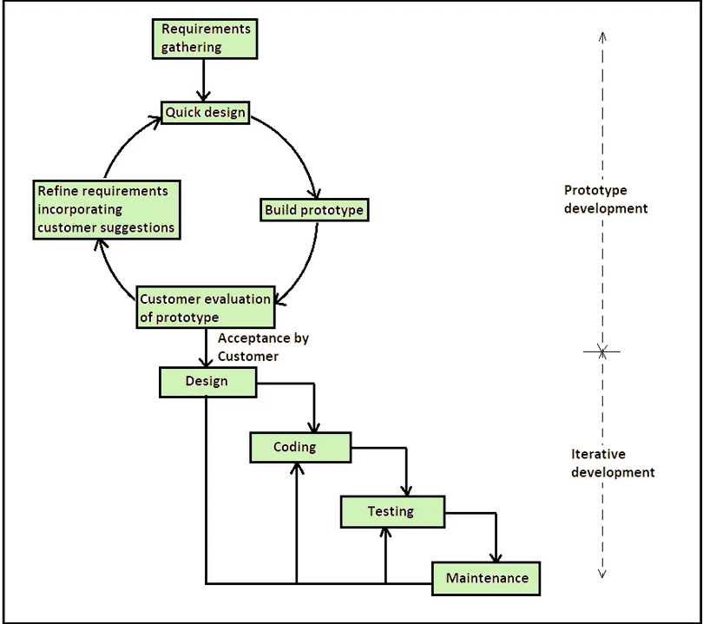
Figure 1:Phototype Model Methodology

Figure 1 shows the Prototype Development Methodology used in this project. The methodology focuses on developing an early version of the Smart KTM Malaysia mobile application to gather feedback and improve the design before actual implementation. This approach is suitable because the project mainly involves designing and evaluating a mobile application prototype using Figma. Through iterative refinement, the prototype can be improved based on user requirements and usability considerations.

4.1.1 Requirement Gathering
During this phase, information related to KTM passenger problems and transportation services was collected from journals, articles and online resources. User requirements such as real-time train tracking, crowd monitoring and online ticket booking were identified.

4.1.2 Quick Design
A preliminary design was created to visualize the system structure and user interface. Wireframes and screen layouts were prepared to represent the key features of the Smart KTM application.

4.1.3 Prototype Development
The prototype was developed using Figma. Various interfaces such as login pages, train tracking maps, crowd monitoring displays and ticket booking screens were created. Interactive navigation and animations were also added.

4.1.4 User Evaluation
The prototype was evaluated to ensure that navigation, interface consistency and usability met user expectations. Feedback was collected and improvements were made where necessary.

4.1.5 Refinement
Based on user feedback, the prototype was refined and enhanced to improve functionality, interface design and overall user experience.

4.2 Approach
This project uses a prototype-based approach to design the Smart KTM Malaysia mobile application. The approach focuses on developing an interactive mobile application prototype that improves user experience and transportation convenience. By using this approach, users are able to visualize and interact with the proposed system before actual implementation.
The prototype approach is suitable for this project because it allows the design and testing of application interfaces such as real time train tracking, crowd monitoring and online ticket booking features. In addition, the approach helps identify user requirements and improve interface usability through interactive design.
Figma software is used to create application prototypes and simulate a realistic mobile application environment. The approach focuses on creating a modern, user friendly and efficient transportation application for KTM passengers in Malaysia.

5.0 Project Plan
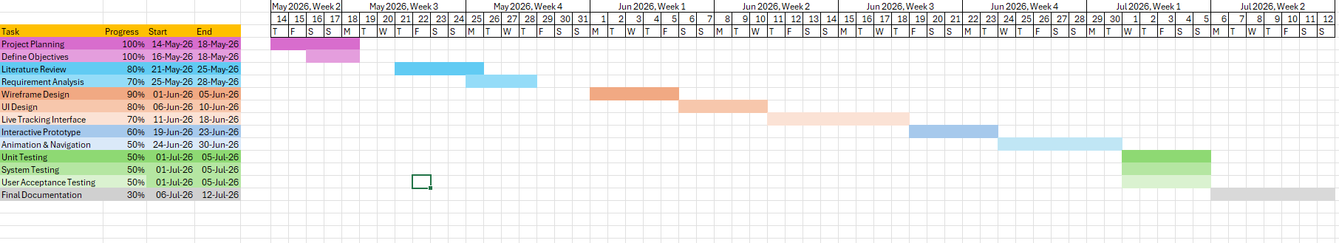
Figure 2: Gantt Chart
The development of the Smart KTM Malaysia application follows a structured timeline covering project planning, design, development, testing, and documentation phases. The project commenced on 14 May 2026 and is scheduled for completion by 12 July 2026.
The project began with the planning phase from 14 May to 18 May 2026, which included defining the project objectives. This was followed by the literature review conducted from 21 May to 25 May 2026. Requirement analysis was carried out from 25 May to 28 May 2026.
The design phase started with wireframe design from 1 June to 5 June 2026, followed by UI design from 6 June to 10 June 2026. The development phase includes the live tracking interface (11-18 June), interactive prototype development (19-23 June) and animation with navigation features (24-30 June).
Testing activities, including unit testing, system testing and user acceptance testing (UAT), are scheduled from 1 July to 5 July 2026. Finally, the final documentation will be prepared from 6 July to 12 July 2026.

6.0 Conclusion
In conclusion, this project proposes the development of a Smart KTM Malaysia mobile application prototype that integrates real-time train tracking, passenger crowd monitoring, and online ticket booking features into a single platform. Based on the literature review, KTM passengers currently face several challenges including unreliable train schedules, overcrowded coaches, lack of real-time information, and inconvenient ticketing processes. These issues negatively affect passenger satisfaction and reduce the efficiency of public transportation services in Malaysia.
To address these problems, the proposed application focuses on three main objectives. First, a passenger monitoring system will be developed to estimate crowd levels in each train coach using sensors. Second, a live train tracking feature will display the current location of trains through an interactive map interface. Third, an online ticket booking function will allow passengers to purchase tickets digitally through their smartphones, reducing the need to queue at station counters.
The project follows Prototype Development Methodology, which includes requirement gathering, quick design, prototype development, user evaluation and refinement. An interactive prototype will be created using Figma to simulate a realistic mobile application experience. The project is scheduled for completion by 12-July 2026.
Overall, the Smart KTM Malaysia application is expected to improve passenger convenience, reduce waiting times, and support the development of smart transportation in Malaysia. By integrating tracking, monitoring, and ticketing features into one platform, the system provides a more efficient, user-friendly, and modern travel experience for KTM passengers.

Reference
- Bachok, S., Osman, M. M., Khalid, U. A., & Ibrahim, M. (2013). Commuters' perceptions
on rail based public transport services: A case study of KTM Komuter in Kuala Lumpur city, Malaysia. Planning Malaysia, 11(3), 99-124.
- Husnina, S. N., Mokhtar, S., Hussein, M. Z. S. M., Hamid, Z. J. M. H., Sinniah, G. K., &
Ghani, N. A. (2022). Factors affecting mobile public transportation applications usage among urban rail transit passengers in Klang Valley, Malaysia. Journal of Computational Science and Intelligent Technologies, 1(1), 1-20.
- K. Ganesh, M. Thrivikraman, J. Kuri, H. Dagale, G. Sudhakar, & S. Sanyal. (2012).
Implementation of a real time passenger information system. arXiv preprint, arXiv:1206.0447.
- Khalid, U. A., Bachok, S., Osman, M. M., & Ibrahim, M. (2014). User perceptions of rail
public transport services in Kuala Lumpur, Malaysia: KTM Komuter. *Procedia - Social and Behavioral Sciences, 153*, 566-573.
- Khor, S. Y., Aruljodey, S., & Shanmugam, K. (2024). Digital challenges to economic
opportunities: Ubiquitous computing in Malaysia's public transportation sector. Journal of Applied Technology and Innovation, 8(2), 1-14.
- Masirin, M. I. M., Salin, A. M., Zainorabidin, A., Martin, D., & Samsuddin, N. (2017).
Review on Malaysian rail transit operation and management system: Issues and solution in integration. IOP Conference Series: Materials Science and Engineering, 226(1), 012029.
- Wahab, S. N., Hamzah, M. I., Suki, N. M., Chong, Y. S., & Kua, C. P. (2025). Unveiling
passenger satisfaction in rail transit through a consumption values perspective. Multimodal Transportation, 4(1), 100196.
- Yusoff, I., Ng, B. K., & Azizan, S. A. (2021). Towards sustainable transport policy
framework: A rail-based transit system in Klang Valley, Malaysia. PLoS ONE, 16(3), e0248519.

